Лаба 3

Рыжевский

Секундомер Время до

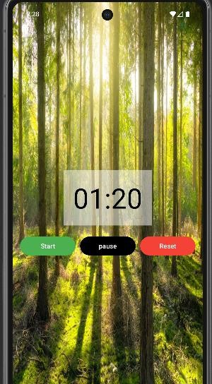

Время после

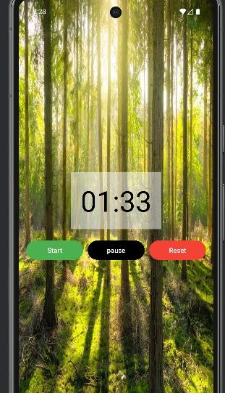

Activity_main.xml

<?xml version="1.0" encoding="utf-8"?>

<LinearLayout

xmlns:android[="http://schemas.android.com/apk/res/android"](http://schemas.android.com/apk/res/android) xmlns:tools[="http://schemas.android.com/tools"](http://schemas.android.com/tools) android:id="@+id/main"

android:layout_width="match_parent" android:layout_height="match_parent" android:orientation="vertical" android:gravity="center" android:padding="16dp" android:background="@drawable/qwer" tools:context=".MainActivity">

<Chronometer

android:id="@+id/textTime" android:layout_width="wrap_content" android:layout_height="wrap_content" android:textSize="60sp" android:layout_gravity="center" android:padding="20dp" android:background="#80FFFFFF"

android:textColor="#000000" android:text="00:00"

/>

<LinearLayout

android:layout_width="wrap_content" android:layout_height="wrap_content" android:orientation="horizontal" android:layout_marginTop="20dp">

<Button

android:id="@+id/btnStart" android:layout_width="wrap_content" android:layout_height="wrap_content" android:text="@string/start" android:layout_marginEnd="10dp" android:minWidth="120dp" android:backgroundTint="#4CAF50" android:textColor="#FFFFFF"

/>

<Button

android:id="@+id/btnPause" android:layout_width="wrap_content" android:layout_height="wrap_content" android:text="@string/pause" android:layout_marginEnd="10dp" android:minWidth="120dp" android:backgroundTint="#000000" android:textColor="#FFFFFF"

/>

<Button

android:id="@+id/btnReset" android:layout_width="wrap_content" android:layout_height="wrap_content" android:text="@string/reset" android:minWidth="120dp" android:backgroundTint="#F44336" android:textColor="#FFFFFF"

/>

</LinearLayout>

</LinearLayout>

MainActivity.kt

package com.example.sekundomer_gleb import android.os.Bundle

import android.os.SystemClock import android.widget.Button import android.widget.Chronometer

import androidx.appcompat.app.AppCompatActivity import com.example.sekundomer_gleb.R

class MainActivity : AppCompatActivity() {

private lateinit var chronometer: Chronometer private var isRunning: Boolean = false private var offset: Long = 0

companion object {

private const val OFFSET_KEY = "offset" private const val RUNNING_KEY = "running"

private const val BASE_KEY = "base"

}

override fun onCreate(savedInstanceState: Bundle?) { super.onCreate(savedInstanceState) setContentView(R.layout.*activity_main*)

chronometer = findViewById(R.id.*textTime*)

val btnStart = findViewById<Button>(R.id.*btnStart*) val btnPause = findViewById<Button>(R.id.*btnPause*) val btnReset = findViewById<Button>(R.id.*btnReset*)

// Восстановление состояния при повороте экрана

if (savedInstanceState != null) {

offset = savedInstanceState.getLong(OFFSET_KEY) isRunning = savedInstanceState.getBoolean(RUNNING_KEY)

if (isRunning) {

chronometer.*base* = savedInstanceState.getLong(BASE_KEY) chronometer.start()

} else {

setBaseTime()

}

}

btnStart.setOnClickListener **{**

if (!isRunning) { setBaseTime() chronometer.start() isRunning = true

}

**}**

btnPause.setOnClickListener **{**

if (isRunning) { saveOffset() chronometer.stop() isRunning = false

}

**}**

btnReset.setOnClickListener **{**

offset = 0 setBaseTime() chronometer.stop() isRunning = false

**}**

}

override fun onSaveInstanceState(outState: Bundle) { super.onSaveInstanceState(outState)

if (isRunning) { saveOffset()

}

outState.putLong(OFFSET_KEY, offset) outState.putBoolean(RUNNING_KEY, isRunning) outState.putLong(BASE_KEY, chronometer.*base*)

}

override fun onPause() { super.onPause()

if (isRunning) { saveOffset() chronometer.stop()

}

}

override fun onResume() { super.onResume()

if (isRunning) { setBaseTime() chronometer.start()

}

}

private fun saveOffset() {

offset = SystemClock.elapsedRealtime() - chronometer.*base*

}

private fun setBaseTime() {

chronometer.*base* = SystemClock.elapsedRealtime() - offset

}

}

strings.xml

<resources>

<string name="app_name">Secundomer_gleb</string> <string name="start">Start</string>

<string name="pause">pause</string>

<string name="reset">Reset</string>

</resources>